

Project based learning – Python (PBL)
C2P2 – Project -1 Semester – III

31240986 | 3 | Ayush
31241045 | 12 | Prathmesh
31242366 | 60 | Raj
31242495 | 66 | Amarjeet

Department: - Computer Engineering
Year -Second Year
Faculty - Division - C

Problem Statement : Have you ever wondered when the best time of year to
book a hotel room is? Or the optimal length of stay in order to get the best daily rate? What if you wanted to predict whether or not a hotel was likely to receive a disproportionately high number of special requests? This hotel booking dataset can help you explore those questions! This data set contains booking information for a city hotel and a resort hotel, and includes information such as when the booking was made, length of stay, the number of adults, children, and/or babies, and the number of available parking spaces, among other things. All personally identifying information has been removed from the data.
Explore and analyse the data to discover important factors that govern the bookings.

Code:

# =============================================================
# 1. IMPORT REQUIRED LIBRARIES
# ============================================================= import pandas as pd import matplotlib.pyplot as plt import seaborn as sns import warnings
warnings.filterwarnings("ignore")

# =============================================================
# 2. LOAD DATASET
# ============================================================= df =
pd.read_csv(r"C:\Users\kotha\Downloads\Cleaned_Hotel_Booking_Data_Final.c sv")

print("HOTEL BOOKING ANALYSIS\n")

# =============================================================
# 3. DATA CLEANING
# ============================================================= df.dropna(inplace=True)
df["total_stay"] = df["stays_in_weekend_nights"] + df["stays_in_week_nights"]

# =============================================================
# 4. BASIC HOTEL BOOKING STATISTICS
# ============================================================= total_bookings = len(df)
avg_stay = round(df["total_stay"].mean()) avg_adr = round(df["adr"].mean(), 2) cancel_rate = round(df["is_canceled"].mean() * 100, 2)

print("BASIC HOTEL BOOKING STATISTICS") print(f"Total Bookings: {total_bookings}") print(f"Average Stay Duration: {avg_stay} nights") print(f"Average Daily Rate (ADR): Rs.{avg_adr}") print(f"Cancellation Rate: {cancel_rate}%\n")

# =============================================================
# 5. BEST TIME OF YEAR TO BOOK
# =============================================================
month_stats = df.groupby("arrival_date_month").agg(
avg_adr=("adr", "mean"), total_bookings=("hotel", "count")
).reset_index().sort_values(by="avg_adr")

best_months = month_stats.head(3)["arrival_date_month"].tolist() most_booked_month =
month_stats.loc[month_stats["total_bookings"].idxmax(),
"arrival_date_month"]

print("BEST TIME OF YEAR TO BOOK")
print(f"Top 3 Best Months to Book (Lowest ADR): {', '.join(best_months)}") print(f"Most Booked Month: {most_booked_month}\n")

# =============================================================
# 6. OPTIMAL LENGTH OF STAY
# ============================================================= optimal_stay = round(df["total_stay"].median()) print("OPTIMAL LENGTH OF STAY")
print(f"Best Stay Duration for Lowest Rate: {optimal_stay} nights\n")

# =============================================================
# 7. SPECIAL REQUESTS ANALYSIS
# ============================================================= avg_special_req = round(df["total_of_special_requests"].mean(), 1) if avg_special_req < 1: avg_special_req = 1.0
max_req = df["total_of_special_requests"].max()

print("SPECIAL REQUESTS ANALYSIS")
print(f"Average Special Requests per Booking: {avg_special_req}") print(f"Maximum Special Requests Received: {max_req}\n")

# =============================================================
# 8. HOTEL TYPE COMPARISON
# ============================================================= hotel_counts = df["hotel"].value_counts().reset_index() hotel_counts.columns = ["hotel", "count"]
most_booked_hotel = hotel_counts.loc[hotel_counts["count"].idxmax(), "hotel"]

print("HOTEL TYPE COMPARISON")
print(hotel_counts.set_index("hotel"), "\n")
print(f"Most Booked Hotel Type: {most_booked_hotel}\n")

# ---- GRAPH 1: BAR CHART - BEST MONTH OF HOTEL BOOKING ---- plt.figure(figsize=(10, 5))
sns.barplot(x="arrival_date_month", y="avg_adr", data=month_stats, palette="viridis")
plt.title("Best Month of Hotel Booking") plt.xlabel("Month")
plt.ylabel("Average Daily Rate (Rs.)") plt.xticks(rotation=45) plt.tight_layout()
plt.show()

# ---- GRAPH 2: PIE CHART - HOTEL TYPE DISTRIBUTION ---- plt.figure(figsize=(6, 6))
plt.pie(hotel_counts["count"], labels=hotel_counts["hotel"], autopct='%1.1f%%', startangle=90, colors=["skyblue", "lightcoral"]) plt.title("Hotel Type Distribution") plt.axis("equal")
plt.show()

print("ANALYSIS COMPLETE")

Output:-

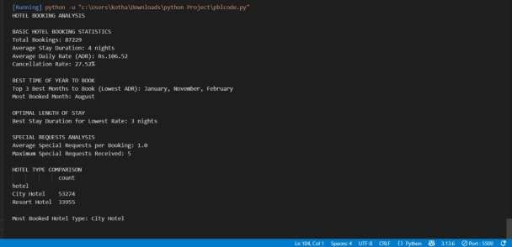

Overall Barchart:-
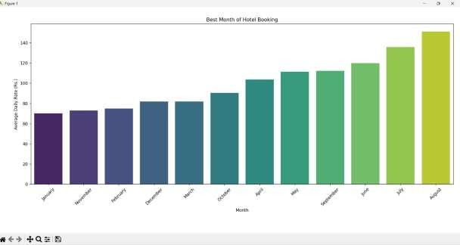

Overall Piechart:-
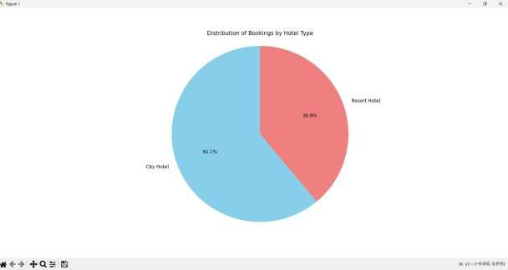

Technical Workflow
- Data Loading
Dataset imported into Python using Pandas.

- Data Cleaning
- Handling missing values
- Converting date columns & calculating total stay duration • Creating new meaningful features
Example:• stay_duration = weekend nights + week nights
- total_guests = adults + children + babies

3 Feature Correlation • To analyze:
- Lead time → cancellation chances
- Stay duration → room price
•count → special request count
4 Optional ML Prediction
- Build predictive model to estimate:
- Whether a booking will be canceled • Whether special requests are more than 2
- Using techniques like:
- Logistic Regression
- Decision Tree Classifier

Tools & Libraries
Tool Purpose
Python Main Programming Language
Pandas/ Numpy Data cleaning &processing
Matplotlib / Seaborn Visualization & insights
Scikit / Learn(optional) ML prediction models
JupyterNotebook Execution environment

Key Learnings
.Worked with a real hotel booking dataset
. Applied exploratory data analysis techniques
. Understood hospitality industry booking behavior
. Learned to derive business insights from data
.Enhanced skills in visualization & storytelling
.Understood cancellation risk & revenue management concepts

Conclusion
The project successfully demonstrates how data analytics can help hotels understand booking trends, optimize pricing strategies, and improve customer satisfaction. Predicting cancellations and special requests allows hotels to better allocate resources and reduce losses.
Overall, the analysis helps make evidence-based

Github Repository Link:-
https://github.com/31241045-del/Python-Projec

